LAB ACTIVITY (Lab-05)
/* Multiplication Table Generator
Write a program to input a number n and print its multiplication table up to 10 using all four loops (for, while, do-while, for-each). */

import java.util.Scanner;

public class multiplication {
public static void main(String[] args) {
Scanner sc = new Scanner(System.in);
System.out.print("Enter a number: ");
int n = sc.nextInt();

System.out.println("\n--- Using for loop ---");
for (int i = 1; i <= 10; i++) {
System.out.println(n + " x " + i + " = " + (n * i));
}

System.out.println("\n--- Using while loop ---");
int i = 1;
while (i <= 10) {
System.out.println(n + " x " + i + " = " + (n * i));
i++;
}

System.out.println("\n--- Using do-while loop ---");
i = 1;
do {
System.out.println(n + " x " + i + " = " + (n * i));
i++;
} while (i <= 10);

System.out.println("\n--- Using for-each loop ---");
int[] nums = {1,2,3,4,5,6,7,8,9,10};
for (int num : nums) {
System.out.println(n + " x " + num + " = " + (n * num));
}

sc.close();
}
}

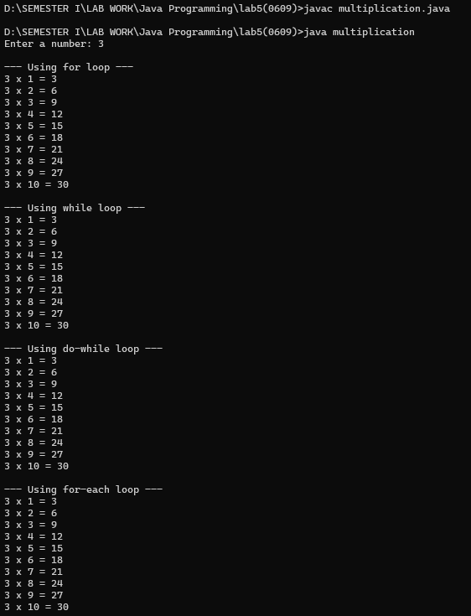

// Factorial of a Number
Write a program to compute the factorial of a given number using all four loops

import java.util.Scanner;

public class FactorialUsingLoops {
public static void main(String[] args) {
Scanner sc = new Scanner(System.in);
System.out.print("Enter a number: ");
int n = sc.nextInt();

// --- Using for loop ---
long factFor = 1;
for (int i = 1; i <= n; i++) {
factFor *= i;
}
System.out.println("Factorial using for loop: " + factFor);

// --- Using while loop ---
long factWhile = 1;
int i = 1;
while (i <= n) {
factWhile *= i;
i++;
}
System.out.println("Factorial using while loop: " + factWhile);

// --- Using do-while loop ---
long factDoWhile = 1;
i = 1;
if (n == 0) { // special case for 0!
factDoWhile = 1;
} else {
do {
factDoWhile *= i;
i++;
} while (i <= n);
}
System.out.println("Factorial using do-while loop: " + factDoWhile);

// --- Using for-each loop ---
long factForEach = 1;
int[] numbers = new int[n];
for (int j = 0; j < n; j++) {
numbers[j] = j + 1;
}
for (int num : numbers) {
factForEach *= num;
}
System.out.println("Factorial using for-each loop: " + factForEach);

sc.close();
}
}

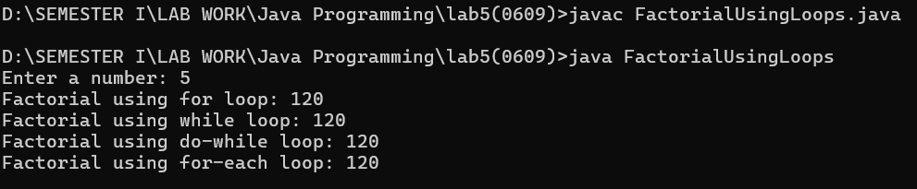

// Reverse a Number
Write a program to reverse the digits of a number using for, while, do-while, and for-each.
import java.util.Scanner;

public class reverse {
public static void main(String[] args) {
Scanner sc = new Scanner(System.in);
System.out.print("Enter a number: ");
int n = sc.nextInt();

// --- Using while loop ---
int num = n;
int revWhile = 0;
while (num > 0) {
int digit = num % 10;
revWhile = revWhile * 10 + digit;
num /= 10;
}
System.out.println("Reverse using while loop: " + revWhile);

// --- Using do-while loop ---
num = n;
int revDoWhile = 0;
if (num == 0) {
revDoWhile = 0;
} else {
do {
int digit = num % 10;
revDoWhile = revDoWhile * 10 + digit;
num /= 10;
} while (num > 0);
}
System.out.println("Reverse using do-while loop: " + revDoWhile);

// --- Using for loop ---
num = n;
int revFor = 0;
for (; num > 0; num /= 10) {
int digit = num % 10;
revFor = revFor * 10 + digit;
}
System.out.println("Reverse using for loop: " + revFor);

// --- Using for-each loop ---
String strNum = Integer.toString(n);
char[] digits = strNum.toCharArray();
String revForEach = "";
for (char d : digits) {
revForEach = d + revForEach; // prepend digit
}
System.out.println("Reverse using for-each loop: " + revForEach);

sc.close();
}
}

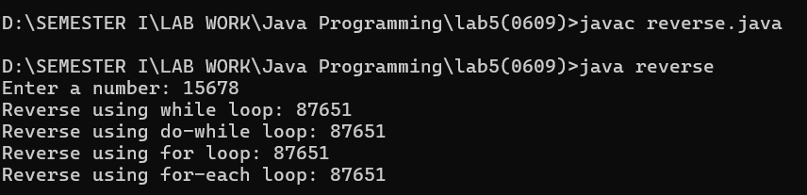

Fibonacci Series
Write a program to generate the first n terms of the Fibonacci sequence using all four loop types

import java.util.Scanner;

public class fibonacci {
public static void main(String[] args) {
Scanner sc = new Scanner(System.in);
System.out.print("Enter number of terms (n): ");
int n = sc.nextInt();

// --- Using for loop ---
System.out.println("\nFibonacci using for loop:");
int a = 0, b = 1;
for (int i = 1; i <= n; i++) {
System.out.print(a + " ");
int next = a + b;
a = b;
b = next;
}

// --- Using while loop ---
System.out.println("\n\nFibonacci using while loop:");
a = 0; b = 1;
int i = 1;
while (i <= n) {
System.out.print(a + " ");
int next = a + b;
a = b;
b = next;
i++;
}

// --- Using do-while loop ---
System.out.println("\n\nFibonacci using do-while loop:");
a = 0; b = 1;
i = 1;
if (n > 0) {
do {
System.out.print(a + " ");
int next = a + b;
a = b;
b = next;
i++;
} while (i <= n);
}

// --- Using for-each loop ---
System.out.println("\n\nFibonacci using for-each loop:");
int[] fibArray = new int[n];
if (n > 0) fibArray[0] = 0;
if (n > 1) fibArray[1] = 1;
for (int j = 2; j < n; j++) {
fibArray[j] = fibArray[j - 1] + fibArray[j - 2];
}
for (int term : fibArray) {
System.out.print(term + " ");
}

sc.close();
}
}

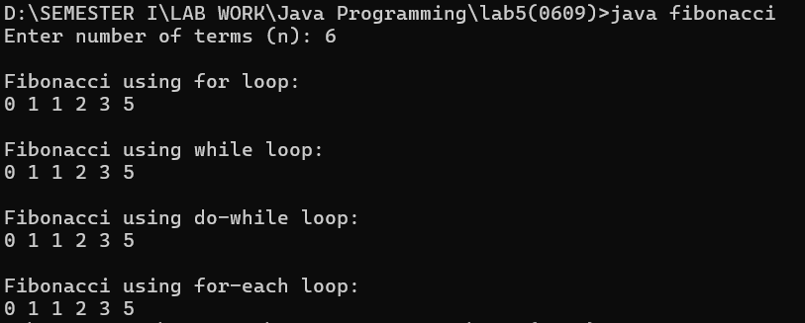

Sum of Digits
Write a program to calculate the sum of digits of a number using all loop types

import java.util.Scanner;

public class SumOfDigits {
public static void main(String[] args) {
Scanner sc = new Scanner(System.in);
System.out.print("Enter a number: ");
int n = sc.nextInt();

// --- Using while loop ---
int num = n;
int sumWhile = 0;
while (num > 0) {
int digit = num % 10;
sumWhile += digit;
num /= 10;
}
System.out.println("Sum using while loop: " + sumWhile);

// --- Using do-while loop ---
num = n;
int sumDoWhile = 0;
if (num == 0) {
sumDoWhile = 0;
} else {
do {
int digit = num % 10;
sumDoWhile += digit;
num /= 10;
} while (num > 0);
}
System.out.println("Sum using do-while loop: " + sumDoWhile);

// --- Using for loop ---
num = n;
int sumFor = 0;
for (; num > 0; num /= 10) {
int digit = num % 10;
sumFor += digit;
}
System.out.println("Sum using for loop: " + sumFor);

// --- Using for-each loop ---
String strNum = Integer.toString(n);
char[] digits = strNum.toCharArray();
int sumForEach = 0;
for (char d : digits) {
sumForEach += Character.getNumericValue(d);
}
System.out.println("Sum using for-each loop: " + sumForEach);

sc.close();
}
}

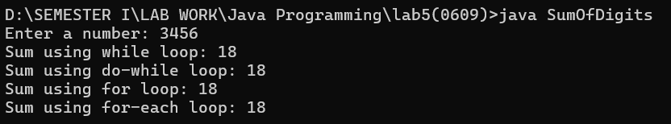

Find Maximum and Minimum in an Array
Write a program to input an array and determine the maximum and minimum element using for, while, do-while, and for-each
import java.util.Scanner;

public class MaxMinArray {
public static void main(String[] args) {
Scanner sc = new Scanner(System.in);

// Input array
System.out.print("Enter size of array: ");
int n = sc.nextInt();
int arr[] = new int[n];

System.out.println("Enter " + n + " elements:");
for (int i = 0; i < n; i++) {
arr[i] = sc.nextInt();
}

// ---------- Using FOR loop ----------
int maxFor = arr[0], minFor = arr[0];
for (int i = 1; i < n; i++) {
if (arr[i] > maxFor) maxFor = arr[i];
if (arr[i] < minFor) minFor = arr[i];
}
System.out.println("FOR loop -> Max: " + maxFor + ", Min: " + minFor);

// ---------- Using WHILE loop ----------
int maxWhile = arr[0], minWhile = arr[0];
int i = 1;
while (i < n) {
if (arr[i] > maxWhile) maxWhile = arr[i];
if (arr[i] < minWhile) minWhile = arr[i];
i++;
}
System.out.println("WHILE loop -> Max: " + maxWhile + ", Min: " + minWhile);

// ---------- Using DO-WHILE loop ----------
int maxDo = arr[0], minDo = arr[0];
int j = 1;
do {
if (arr[j] > maxDo) maxDo = arr[j];
if (arr[j] < minDo) minDo = arr[j];
j++;
} while (j < n);
System.out.println("DO-WHILE loop -> Max: " + maxDo + ", Min: " + minDo);

// ---------- Using FOR-EACH loop ----------
int maxFE = arr[0], minFE = arr[0];
for (int val : arr) {
if (val > maxFE) maxFE = val;
if (val < minFE) minFE = val;
}
System.out.println("FOR-EACH loop -> Max: " + maxFE + ", Min: " + minFE);

sc.close();
}
}
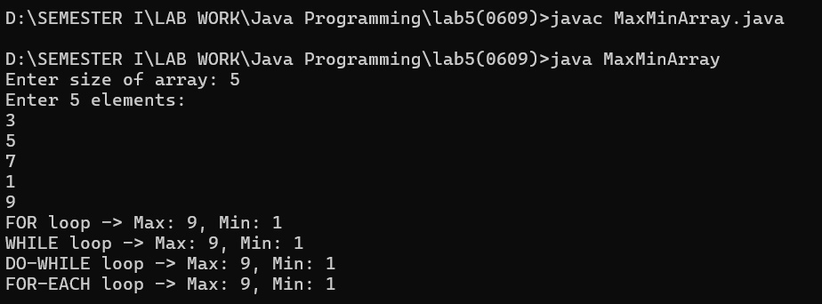

Prime Number Check
Write a program to check whether a given number is prime or not using all loop variations.
import java.util.Scanner;

public class PrimeCheck {
public static void main(String[] args) {
Scanner sc = new Scanner(System.in);

// Input number
System.out.print("Enter a number: ");
int n = sc.nextInt();

// ---------- Using FOR loop ----------
boolean isPrimeFor = true;
if (n <= 1) {
isPrimeFor = false;
} else {
for (int i = 2; i <= n / 2; i++) {
if (n % i == 0) {
isPrimeFor = false;
break;
}
}
}
System.out.println("FOR loop -> " + (isPrimeFor ? "Prime" : "Not Prime"));

// ---------- Using WHILE loop ----------
boolean isPrimeWhile = true;
if (n <= 1) {
isPrimeWhile = false;
} else {
int i = 2;
while (i <= n / 2) {
if (n % i == 0) {
isPrimeWhile = false;
break;
}
i++;
}
}
System.out.println("WHILE loop -> " + (isPrimeWhile ? "Prime" : "Not Prime"));

// ---------- Using DO-WHILE loop ----------
boolean isPrimeDo = true;
if (n <= 1) {
isPrimeDo = false;
} else {
int i = 2;
do {
if (n % i == 0) {
isPrimeDo = false;
break;
}
i++;
} while (i <= n / 2);
}
System.out.println("DO-WHILE loop -> " + (isPrimeDo ? "Prime" : "Not Prime"));

// ---------- Using FOR-EACH loop ----------

boolean isPrimeFE = true;
if (n <= 1) {
isPrimeFE = false;
} else {
int[] divisors = new int[n / 2 - 1];
for (int i = 0; i < divisors.length; i++) {
divisors[i] = i + 2;
}

for (int d : divisors) {
if (n % d == 0) {
isPrimeFE = false;
break;
}
}
}
System.out.println("FOR-EACH loop -> " + (isPrimeFE ? "Prime" : "Not Prime"));

sc.close();
}
}

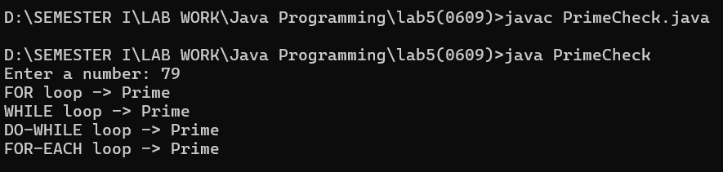

Palindrome Checker
Write a program to check whether a string or number is a palindrome using different loops.

import java.util.Scanner;

public class PalindromeChecker {
public static void main(String[] args) {
Scanner sc = new Scanner(System.in);

// Input string/number
System.out.print("Enter a string or number: ");
String input = sc.nextLine();

// Normalize input (optional, in case user types spaces/case differences)
String str = input.toLowerCase().replaceAll("\\s+", "");

// ---------- Using FOR loop ----------
boolean isPalindromeFor = true;
for (int i = 0; i < str.length() / 2; i++) {
if (str.charAt(i) != str.charAt(str.length() - 1 - i)) {
isPalindromeFor = false;
break;
}
}
System.out.println("FOR loop -> " + (isPalindromeFor ? "Palindrome" : "Not Palindrome"));

// ---------- Using WHILE loop ----------
boolean isPalindromeWhile = true;
int left = 0, right = str.length() - 1;
while (left < right) {
if (str.charAt(left) != str.charAt(right)) {
isPalindromeWhile = false;
break;
}
left++;
right--;
}
System.out.println("WHILE loop -> " + (isPalindromeWhile ? "Palindrome" : "Not Palindrome"));

// ---------- Using DO-WHILE loop ----------
boolean isPalindromeDo = true;
int l = 0, r = str.length() - 1;
if (str.length() > 1) { // avoid empty string issue
do {
if (str.charAt(l) != str.charAt(r)) {
isPalindromeDo = false;
break;
}
l++;
r--;
} while (l < r);
}
System.out.println("DO-WHILE loop -> " + (isPalindromeDo ? "Palindrome" : "Not Palindrome"));

// ---------- Using FOR-EACH loop ----------
StringBuilder reversed = new StringBuilder();
for (char c : str.toCharArray()) {
reversed.insert(0, c); // build reversed string
}
boolean isPalindromeFE = str.equals(reversed.toString());
System.out.println("FOR-EACH loop -> " + (isPalindromeFE ? "Palindrome" : "Not Palindrome"));

sc.close();
}
}

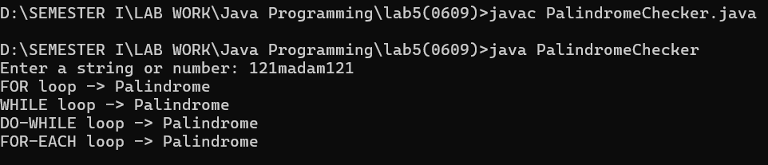

Matrix Traversal
Write a program to input a 2D matrix and print its elements row-wise and column-wise using for, while, do-while, and for-each.
import java.util.Scanner;

public class MatrixTraversal {
public static void main(String[] args) {
Scanner sc = new Scanner(System.in);

// Input matrix size
System.out.print("Enter number of rows: ");
int rows = sc.nextInt();
System.out.print("Enter number of columns: ");
int cols = sc.nextInt();

int[][] matrix = new int[rows][cols];

// Input matrix elements
System.out.println("Enter elements of matrix:");
for (int i = 0; i < rows; i++) {
for (int j = 0; j < cols; j++) {
matrix[i][j] = sc.nextInt();
}
}

System.out.println("\n--- Row-wise Traversal ---");

// ---------- FOR loop ----------
System.out.println("FOR loop:");
for (int i = 0; i < rows; i++) {
for (int j = 0; j < cols; j++) {
System.out.print(matrix[i][j] + " ");
}
System.out.println();
}

// ---------- WHILE loop ----------
System.out.println("WHILE loop:");
int i = 0;
while (i < rows) {
int j = 0;
while (j < cols) {
System.out.print(matrix[i][j] + " ");
j++;
}
System.out.println();
i++;
}

// ---------- DO-WHILE loop ----------
System.out.println("DO-WHILE loop:");
int r = 0;
if (rows > 0 && cols > 0) {
do {
int c = 0;
do {
System.out.print(matrix[r][c] + " ");
c++;
} while (c < cols);
System.out.println();
r++;
} while (r < rows);
}

// ---------- FOR-EACH loop ----------
System.out.println("FOR-EACH loop:");
for (int[] row : matrix) {
for (int val : row) {
System.out.print(val + " ");
}
System.out.println();
}

System.out.println("\n--- Column-wise Traversal ---");

// ---------- FOR loop ----------
System.out.println("FOR loop:");
for (int j = 0; j < cols; j++) {
for (int k = 0; k < rows; k++) {
System.out.print(matrix[k][j] + " ");
}
System.out.println();
}

// ---------- WHILE loop ----------
System.out.println("WHILE loop:");
int c1 = 0;
while (c1 < cols) {
int r1 = 0;
while (r1 < rows) {
System.out.print(matrix[r1][c1] + " ");
r1++;
}
System.out.println();
c1++;
}

// ---------- DO-WHILE loop ----------
System.out.println("DO-WHILE loop:");
int c2 = 0;
if (rows > 0 && cols > 0) {
do {
int r2 = 0;
do {
System.out.print(matrix[r2][c2] + " ");
r2++;
} while (r2 < rows);
System.out.println();
c2++;
} while (c2 < cols);
}

// ---------- FOR-EACH loop (Trick: Not direct, so transpose logic) ----------
System.out.println("FOR-EACH loop:");
for (int j = 0; j < cols; j++) {
for (int[] row : matrix) {
System.out.print(row[j] + " ");
}
System.out.println();
}
sc.close();
}
}
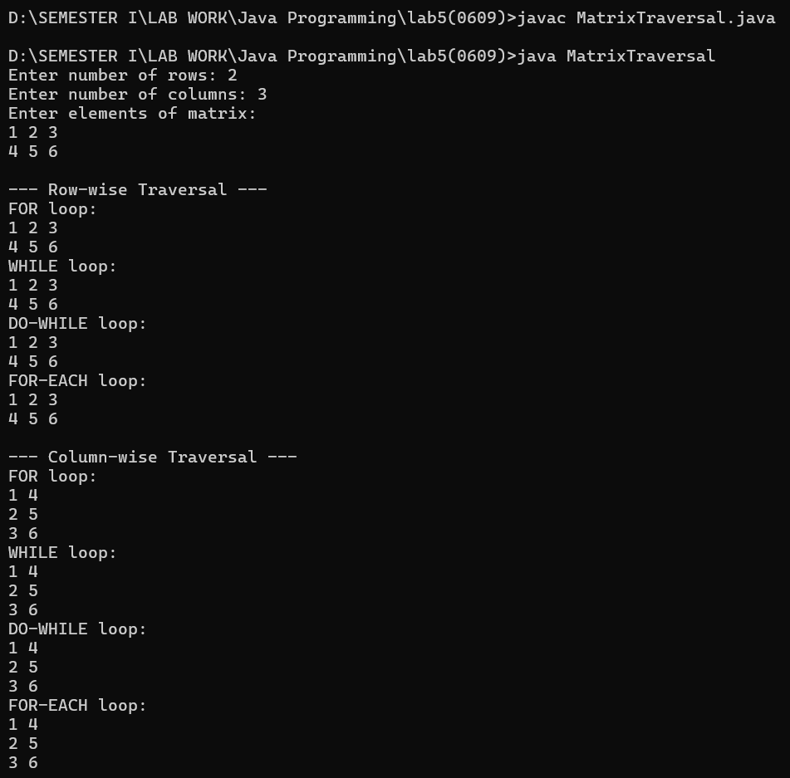

Pattern Printing
Write a program to print the following pattern using all loops:
*
**
***
****

import java.util.Scanner;

public class PatternPrinting {
public static void main(String[] args) {
Scanner sc = new Scanner(System.in);

// Input number of rows
System.out.print("Enter number of rows: ");
int n = sc.nextInt();

// ---------- FOR loop ----------
System.out.println("FOR loop:");
for (int i = 1; i <= n; i++) {
for (int j = 1; j <= i; j++) {
System.out.print("*");
}
System.out.println();
}

// ---------- WHILE loop ----------
System.out.println("WHILE loop:");
int i = 1;
while (i <= n) {
int j = 1;
while (j <= i) {
System.out.print("*");
j++;
}
System.out.println();
i++;
}

// ---------- DO-WHILE loop ----------
System.out.println("DO-WHILE loop:");
int r = 1;
do {
int c = 1;
do {
System.out.print("*");
c++;
} while (c <= r);
System.out.println();
r++;
} while (r <= n);

// ---------- FOR-EACH loop (Trick: simulate with array of row numbers) ----------
System.out.println("FOR-EACH loop:");
int[] rows = new int[n];
for (int k = 0; k < n; k++) {
rows[k] = k + 1;
}
for (int row : rows) {
for (int j = 1; j <= row; j++) {
System.out.print("*");
}
System.out.println();
}

sc.close();
}
}
